**Basics**

<!DOCTYPE> Defines the document type

<html> Defines an HTML document

<title> Defines a title for the document

<body> Defines the document's body

<h1> to <h6> Defines HTML headings

<p> Defines a paragraph

<br> Inserts a single line break

<!--YOUR COMMENT HERE--> Defines comment - describes file, invisible on webpage

**Formatting**

<abbr title=”Long Name For Thing”> Defines an abbreviation or an acronym

<b> Defines **bold** text

<blockquote> Defines a section that is quoted from another source

<code> Defines a piece of computer code formatting

<i> Defines a part of text in *italics*

<mark> Defines marked/highlighted text

<meter value=”2” min=”0” max=”10”> Defines a scalar measurement within a known range

<progress value=”32” max=”100”> Represents the progress of a task

<s> Defines text that is no longer ~~correct~~

<small> Defines smaller text

<strong> Defines important **text**

<sub> Defines subscripted text

<sup> Defines superscripted text

<u> Defines underlined text

**Styling (Not CSS)**

<style> Defines style information for a document

<div> Defines a section in a document

<details> Defines additional details that the user can view or hide

<summary> Defines a visible heading for a <details> element

<dialog open> Defines a dialog box or window

**Lists & Tables**

<ul> Defines an unordered list

<ol> Defines an ordered list

<li> Defines a list item

<table> Defines a table

<th> Defines a header cell in a table

<tr> Defines a row in a table

<td> Defines a cell in a table

**Examples**

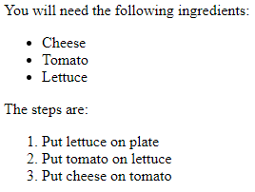

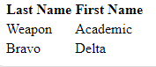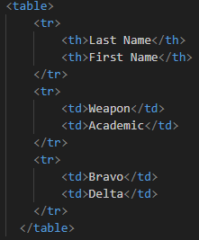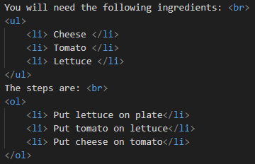

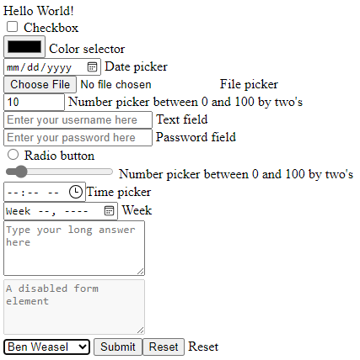**Forms and Input**

<form> Defines an HTML form for user input

<input> Defines an input control

<textarea> Defines a multiline input control (text area)

<button> Defines a clickable button

<select> Defines a drop-down list

<option> Defines an option in a drop-down list

<output> Defines the result of a calculation

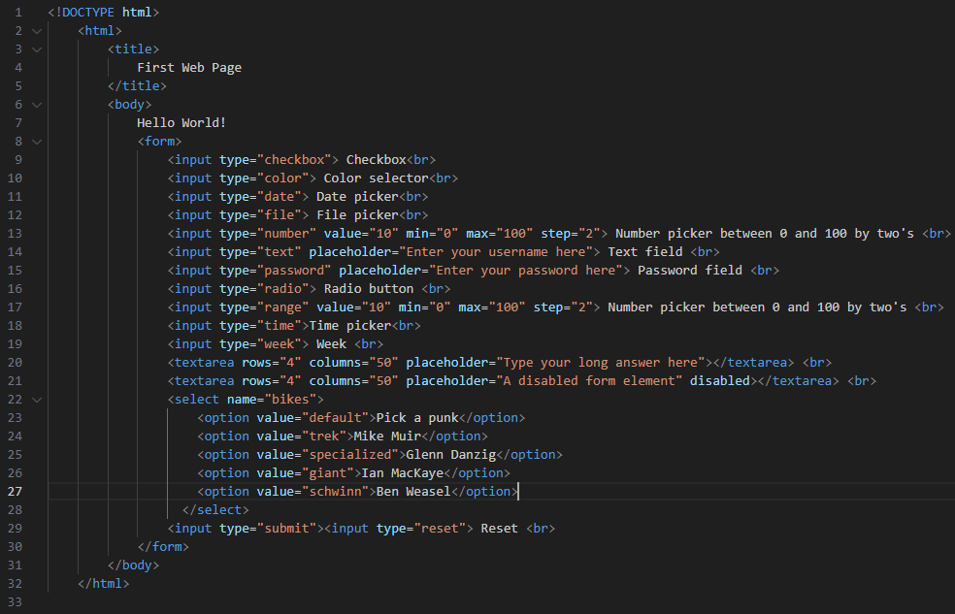

**Media & Miscellaneous**

<img> Defines an image

<canvas> Used to draw graphics, on the fly, via scripting (usually JavaScript)

<audio> Defines sound content

<video> Defines a video or movie

<source> Defines multiple media resources for media elements (<video>, <audio> and <picture>)

<a> Defines a hyperlink

<script > Defines a client-side script

**Examples**

<img src="image_name.file_type" alt="Description of image" width="500" height="600">

<canvas id=”game” width=”800” height=”600”/>

<audio controls>

<source src="sound_name.file_type" type="audio/mpeg">

</audio>

<video width="320" height="240" controls>

<source src="video_name.file_type " type="video/mp4">

</video>

<a href="https://google.com ">Go to Google.com </a>

**CSS (Intro)**

